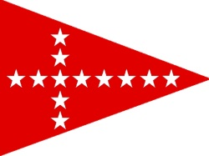
August 28 - 29
2018 JY15 NA Championship

Sayville Yacht Club

Notice
NOR 4 has been removed due to Regatta Tech’s Closing.
NOR 6.1 has been changed “A maximum of nine(9) races may be sailed.”
NOR 6.2 A Skipper’s Meeting at 1000 Saturday 7/28 has been added.

Registrations can be made at Yacht scoring: https://www.yachtscoring.com/event_registration_email.cfm

1800 7/27/2018

